Chapter 10, Solution 29.

Using Fig. 10.77, design a problem to help other students better understand mesh analysis.

Although there are many ways to work this problem, this is an example based on the same kind of problem asked in the third edition.

Problem

By using mesh analysis, find I₁ and I₂ in the circuit depicted in Fig. 10.77.

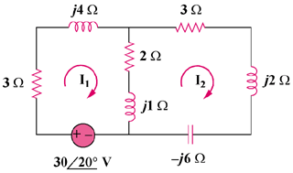

Figure 10.77

Solution

For mesh 1,
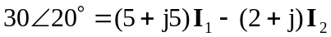 (1)

For mesh 2,
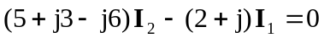
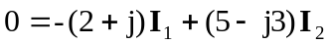 (2)

From (1) and (2),
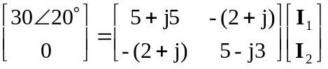

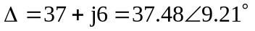

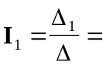 4.67–20.17 A

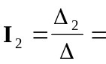 1.7937.35 A

